

|  |  |  |  |  |  |  |  |  |
| --- | --- | --- | --- | --- | --- | --- | --- | --- |
|  | | | | | | | | |
|  | | Spreadsheet System Report | | | | |  | |
|  |  | | | | | | |  |
|  | | | |  |  | | | |
|  | | | | Abdullah Alabdullah |  | | | |
|  | | | | 13/12/2020—Developing Spreadsheet Applications |  | | | |
|  | | |  | | |  | | |

Introduction:

The spreadsheet system has been created at the request of Big Data Corporation Academy. The system will support members of staff to track students’ progress. In this report, I will identify the functions used in the spreadsheet system. I will then explain how the spreadsheet system meets end-user requirements. I will conclude by providing some alternative functions and evaluating the spreadsheet system.

What functions were used?

Functions in excel are extremely helpful tools that can improve your performance and make your work more accurate. The wonderful thing about these functions is that they are anything but difficult to use.

In my spreadsheet system, I have utilized a lot of different functions, including:

1. Logical functions: (like IF and IFERROR).
2. Lookup and Reference functions: (like VLOOKUP).
3. Math functions: (like SUM and Division).
4. Statistical functions: (like AVERAGE, COUNTA, COUNTIF, MAX and MIN).
5. Other functions: (like Macros, Charts, Conditional Formatting, Protect sheet, Hide sheet, Pivot tables and Slicers).

Why were the functions used?

1. Logical functions:

* IF: In the second sheet of my project, this function was used to display a warning message to the tutor if any of the student’s marks are below 25. Furthermore, this function was very useful to use in the course sheet because it helped me classify students’ grades into four main grades: distinction, merit, pass and no grade.
* IFERROR: Sometimes you might get an unexpected value (like # DIV / 0! Or # N/A or #VALUE!) due to some reasons. It is useful to replace these error messages with more meaningful ones (like enter a valid value or not found). To do this, you should consider using the IFERROR function. In the "student search" sheet, this function was used with VLOOKUP to search for students’ data throughout multiple sheets.

1. Lookup and Reference functions:

* VLOOKUP: This function was utilized in the "student search" sheet. Once the student’s first name is entered, this function starts searching for the student’s first name throughout multiple sheets. Once the name is found, VLOOKUP can extract relevant information associated with the first name.

1. Math functions:

* SUM: I have used this simple function to calculate the total mark for the modular exams for each student.
* Division: This short formula was used to calculate percentages for each exam.

1. Statistical functions:

* AVERAGE: This function was utilized to work out the average mark for each course.
* COUNTA: The main purpose of using this function is to count the number of non-blank cells. In my project, I have taken advantage of this function to count the number of students per course.
* COUNTIF: I have utilized this function to count the number of students who have achieved distinction, merit, pass, and no grade.
* MAX: This function was utilized to find out the best mark accomplished in each class.
* MIN: The MIN function was used to find out the lowest mark achieved in each class.

1. Other functions:

* Macros: For tasks that you perform repeatedly, it is advantageous to use the macro recorder. With the assistance of the macro recorder, we can record any function or task and assign it to a button, as you can click the button at any time to perform the same task. In the spreadsheet system, this function was used to easily navigate between different sheets. In addition, recorded macros were used to sort data alphabetically.
* Charts: Although there are different types of charts that can be used to display data, I have used clustered charts to display students’ grades and total marks. Cluster charts are best used when the order of categories is not important.
* Conditional Formatting: Conditional formatting gives you the ability to highlight important data. I have made use of this function to mark students’ grades with different colors in order to make them more readable.
* Pivot tables: Data analysis is no longer a difficult task thanks to pivot tables. With pivot tables, we can handily analyze and summarize a vast amount of data. I have used a pivot table to create an analysis sheet, where tutors can make comparisons between students.
* Slicers: A set of slicers was created to control the data displayed in the pivot table. For example, tutors can click any button in the slicer to filter the data shown in the pivot table.
* Protect sheet: This function was used in my project to restrict others from editing the work. The workbook is fully protected, except for the "First Name" cell on the "Student search" sheet. You may also notice that protecting sheets does not prevent users from using the pivot table and slicers.
* Hide sheet: In my project, I had to hide two sheets. The first sheet (Data_valid) contains a validated list of all student names in all courses. This list is called in the Student Search sheet to create a drop-down list of all student names. The main purpose of hiding this sheet is not to be seen by users. Moreover, it helps in keeping the data secure and preventing users from making any changes to it. The second hidden sheet is the "resource" sheet. This sheet contains all the data needed to create the pivot table. The importance of hiding this sheet is to make the workbook more organized by hiding sheets that users may not need to access.

How does the Spreadsheet System meet end-user requirements?

The spreadsheet system was designed to satisfy specific end-user requirements. All these requirements have been successfully met in the spreadsheet system.

Features of the spreadsheet system:

* The spreadsheet system can be easily navigated with the navigation buttons included on each sheet.
* Tutors can input student names into a search engine to retrieve relevant information.
* A warning message will appear on the "Student search" sheet if any of the student’s marks are less than 25.
* The total number of marks for the modular exams is available for each student in the "Student search" sheet.
* Each level has a separate sheet that contains all relevant students’ data.
* Each student has a mark, grade, and percentage available for each modular and mock exam.
* For every enrolled student, tutors can see a number that represents the total number of marks achieved for the modular exams.
* Different formatting functions were utilized to highlight important data and make them more readable.
* Each cohort has a table representing the number of students who have achieved distinction, merit, pass, and no grade.
* Data can be sorted alphabetically using the sort buttons.
* Data relevant to each course is available in a separate data analysis sheet.
* The data displayed in the pivot table can be easily controlled using slicers.

Could any alternative functions be used to enhance performance?

Although I have used a range of functions to enhance the performance of my work, there are a lot of other functions that can also be used, including:

* More conditional formatting functions like icons and color scales.
* Count: This function can be used to count the number of students per course.
* AutoSum: This is a quick way to do some calculations.
* Freez top row: Using this function makes it easier to navigate the sheet.
* Index and Match: These functions can be used as an alternative to VLOOKUP.

How to use Index and Match instead of VLOOKUP?

Unlike VLOOKUP, the Match function can only locate the data you are looking for (the column/row number where the data is located).

Formula:



In this formula, the data we are looking for is the lookup_value. This value can be specified manually by typing the text in quotation marks or by selecting a cell containing the lookup_value. The second argument is the range of cells in which the data might be located. It must be noted that the Match function allows you to select only one dimension (single column or row). The last argument is the match type, which allows you to specify a condition for the data you are looking for, such as less than (<), greater than (>) or 0 (exact match).

The index function can also be used in place of VLOOKUP. The main difference between the two functions is that the return value in the index function is based on a specific row and column. To simplify matters, look at the following formula:

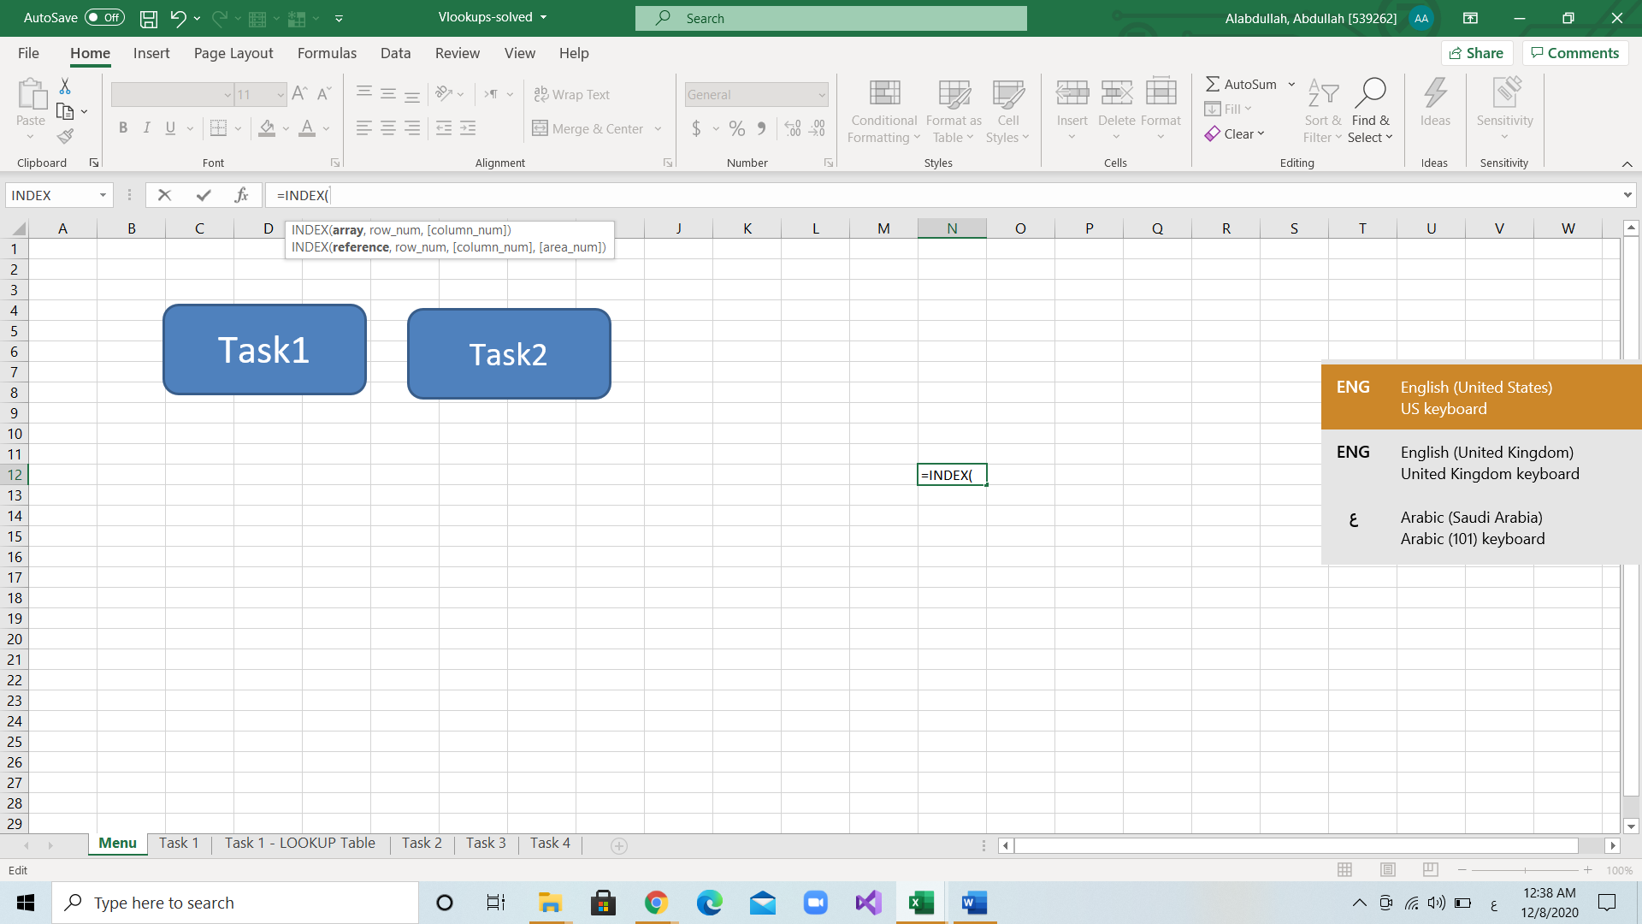

The array argument represents the range of cells in which the data might be located. The second argument is the column number. When the array range is only one column; you do not need to specify the last argument (column_num).

Although Index and Match can be used alone, using them together can create a more powerful tool.

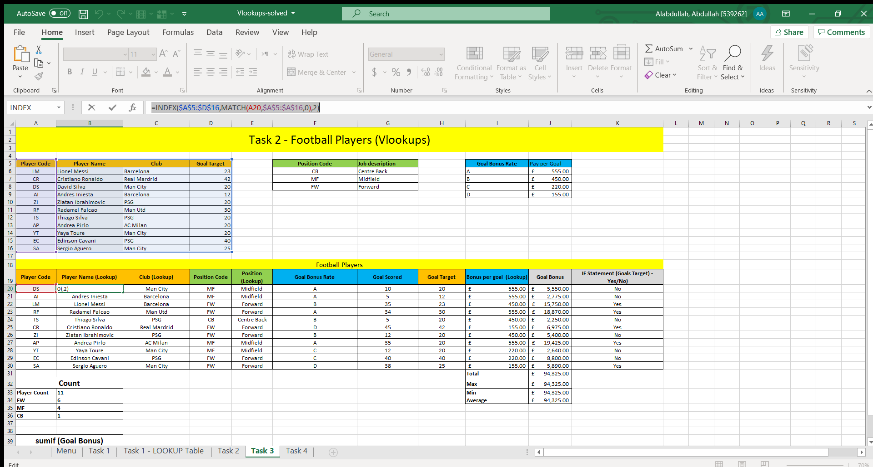

The first value shown in the example above is the array. The Match function is used in the second argument in place of the row_num. The last digit (2) represents the column number, which can be removed if the array range is only one column.

Using Index and Match, we can define a single column that contains the values. However, in VLOOKUP, we need to define the entire table. Hence, if a column is removed from the table; VLOOKUP will break. On the other hand, I used VLOOKUP because it is simpler and easier. Moreover, my spreadsheets contain a fixed number of columns, thus, it is unlikely that any errors will occur in the future. Another benefit of using VLOOKUP is that VLOOKUP is not case-sensitive.

How to use other functions in Excel?

* IF: This function is used to check whether a condition is met. It also returns one value if the condition is met (true) and another value if the condition is not met (false). The first argument in this formula is logical_test, which evaluates whether the given value is true or false. If the value is true, then value_if_true is displayed. When the value is false, the last argument value is displayed.

**Formula:**



**Function Arguments:**

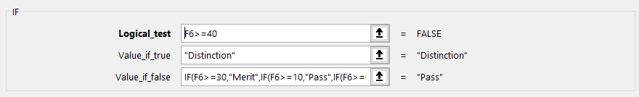

**Example:**



* IFERROR: The first argument is the expression/task that you want to perform. If the expression results in an error like #DIV/0!, value_if_error will be displayed.

**Formula**:

**Function Arguments:**

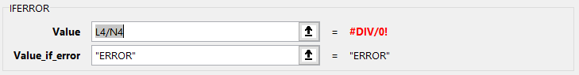

**Example:**

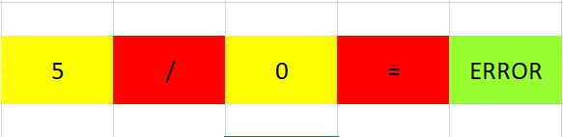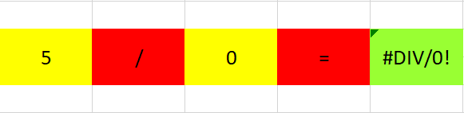

Before

After

* VLOOKUP: To use this function, you will need to specify the lookup value or select a cell that contains the value. The second step is to select the range of cells in which you want to look up for the value. The third argument (Col_index_num) is the column number that contains the data you are looking for. The last argument has only two values, false and true. The value "false" can be used when looking for an exact match. However, if the value is set to "true", it will look for an approximate match.

**Formula:**



**Function Arguments:**

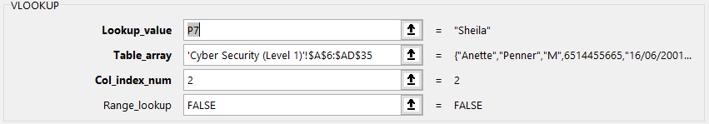

**Example:**

* COUNTA: This function can be used easily by selecting the range of cells you want to count.

**Formula:**



**Function Arguments:**

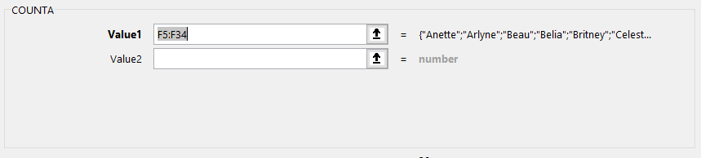

**Example:**

* COUNTIF: The first argument in this formula is the range of cells in which you want to look for cells that meet the criteria specified in the second argument.

**Formula:**



**Function Arguments:**

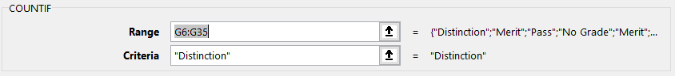

**Example:**



* Macros: You can start recording any task by clicking on "Record Macro" from the "View" window. You will then need to give your macro a memorable name, which will be used when assigning it to a button. Once the task is recorded, you can stop recording from the "View" window. The macro can now be assigned to a shape. When you click on the shape, the recorded task is executed.

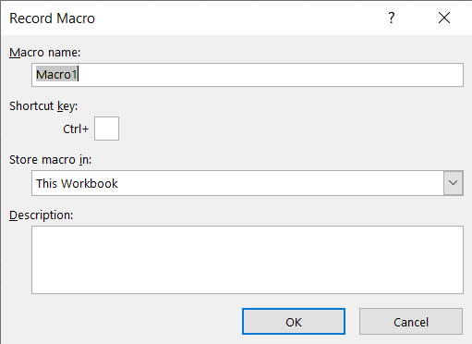

* Pivot table: To create a pivot table, you will need to select the table or data source you want to use and then click on PivotChart from the "Insert" window. From the window shown below (Figure 1), you can choose to insert the pivot table into a new worksheet or use the existing worksheet instead. After which, you can control the data displayed in the pivot table using PivotTable fields (Figure 2).

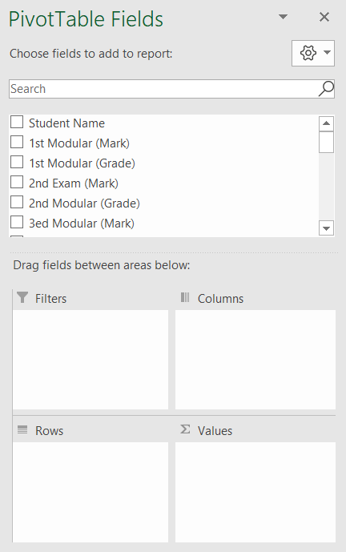

Figure 2

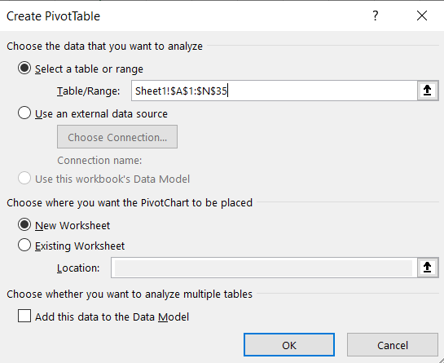

Figure 1

* Slicer: To insert a Slicer, you have to select the pivot table you created and click on "Slicer" from the "Insert" window. You can then decide which values to include in your slicer (Figure 1).

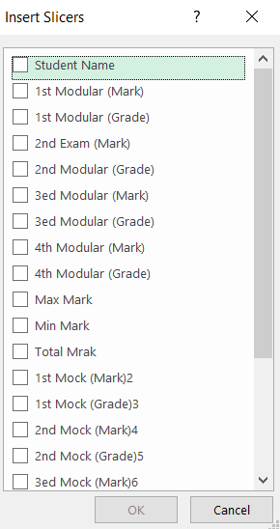

Figure 1

Functions for analyzing, manipulating, and interpreting data:

Excel has hundreds of different functions that can be used to analyze data like:

* FIND: This function can be very effective when searching for something in your workbook without the need to scroll through a long list.
* REPLACE: This function is very similar to the "FIND" function, but it gives you the ability to replace the found data.
* RANK: A simple example of using this function is to rank students’ grades in ascending or descending order.
* TRIM: The main use of this function is to eliminate blank spaces at the beginning and end of some values.
* AVERAGEIF: This function can be applied to my project for calculating the females’ average exam mark.

Spreadsheet System Evaluation:

The spreadsheet system has been created for members of staff to use to keep tabs on students’ progress. Lots of functions and formulas were used throughout the workbook to enhance tutors’ experience and make it easier to track students’ progress and identify relevant data, such as the average mark, highest mark, and lowest mark. The spreadsheet system is easy to use and contains all the information required for all courses.